Prelude to Prayer: Excerpt from The Broken Way by: Ann Voskamp

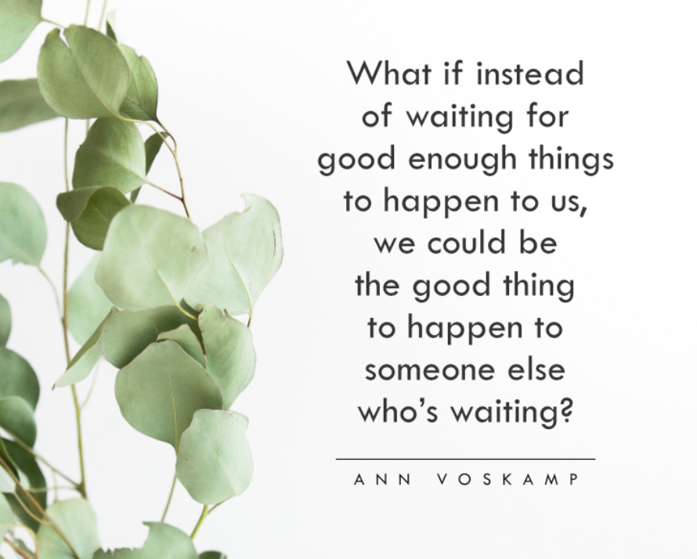

John 13: 1-5
It was just before the Passover Festival. Jesus knew that the hour had come for him to leave this world and go to the Father. Having loved his own who were in the world, he loved them to the end.
The evening meal was in progress, and the devil had already prompted Judas, the son of Simon Iscariot, to betray Jesus. Jesus knew that the Father had put all things under his power, and that he had come from God and was returning to God; so he got up from the meal, took off his outer clothing, and wrapped a towel around his waist. After that, he poured water into a basin and began to wash his disciples’ feet, drying them with the towel that was wrapped around him.
- It was just before You were rejected and tortured, and here You are, washing your disciples. Here, see You, bending down, to serve. You saw people and You had compassion. You see me, You see all of the details of my life, and You have compassion on me too.
- I saw You this week working in ways that I know, are only possible because of You. Thank You Jesus for…
- You are my focus. When there is chaos around me, just thinking about You brings calm. I love how You love, me. I’m coming to You this morning, rejoicing that I’m loved by You. You take time for me. You speak to me. You lead me. You teach me. You change me.
John 13: 34-35
“A new command I give you: Love one another. As I have loved you, so you must love one another. By this everyone will know that you are my disciples, if you love one another.”
- Loving others above myself doesn’t always come easy for me. I see You have given me a new commandment.
- When I see others loving me, I see Your love extended through them. I don’t see just them, I see Your heart.
- Thank You for how _______ loves me. I know they are Your disciple, and they are learning from You. What a gift that I get to be the recipient of this kind of love.
- I need to actually see beyond the surface to know how to love others. Help me not see with only physical eyes, and pesky planks filled with judgement. Remove whatever is in me, that prevents me from really seeing others and desiring to respond. Then, enable me to see, and respond in love.
- Take my mind, wash my thoughts with living water. Sanctify my mind, to be set apart for You.
- Take my words, transform them to be words that build up.
- Take my actions, multiply the works of my hands.
- From my mind, to my words to my actions, let it all be a gift poured back to You, loving others with all that You’ve given me.
- When I’m empty and I don’t know what to give, show me what I do have, show me what You’ve already placed in me. I’ll keep coming back to You again and again, to get filled up, so I pour out.
- Come Lord Jesus come, and give me direction please, especially in my love and response towards _______________.
- The impact, the lasting impact is not so that others will know I loved them well, and know my name. It’s so Your name goes forth, Your message goes out, and salvation is accepted. What a relief it’s not about me. To You be the glory Lord, now and forever more.
- In Jesus’ name, amen.

